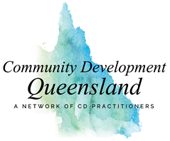

Trainers and consultants who contribute to the field of community development and would like to be included on our website, please provide information below. See cdq.org to familiarise yourself with the practice principles we promote. This will inform the training we promote.

Please also provide your logo or portrait photo as a jpeg or png file attached to the email when sending this form (do not copy and paste any images into the form below)

Contact Details
Your Name
Company (if relevant)
Email and phone
Webpage/other social media, eg LinkedIn, business FB page
Region you will work within, eg Bris, Rockhampton, Qld

Headline Choose a unique Headline for your webpage entry

What you Offer
Maximum 10-15 words
eg Workshops in Community Development at beginner level

eg Developmental evaluation
Reflective and Quantitative tracking for learning and accountability

Bio
Name
Maximum 150 words, covering three things: Your orientation (beliefs that inform where you are coming from) your areas of expertise, and how you approach your work.

Email completed form and image(s) to: CDQtraining@gmail.com

